CALL FOR SUBMISSIONS:
Community engagement for inclusive rural transformation and gender equality
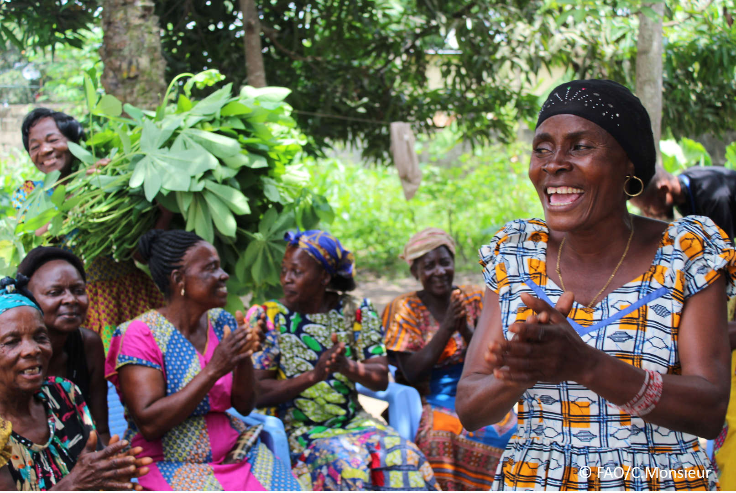
The objective of this call for submissions is to collect good practices, experiences, and lessons learnt on the use of community engagement for inclusive rural transformation and gender equality. The initiative, organized by the Rural Transformation and Gender Equality Division (ESP), seeks to gather insights from a diverse range of contributors, both within FAO and from external stakeholders. Its goal is to share knowledge, foster learning, and guide the scaling up of community engagement and community-led collective action to leave no one behind. The call builds on FAO's past efforts in this area, such as the Community Engagement Days series of webinars.
The call for submissions is open until 27 November 2024.

How to take part in this call for submissions:
To take part in this Call for submissions, please register to the FSN Forum, if you are not yet a member, or “sign in” to your account. Please review the topic note to understand the criteria we are considering for this call. If you wish to learn more about community engagement, you may refer to the background document. Once you have completed this submission template, upload it in the box “Post your contribution” on the call webpage, or, alternatively, send it to fsn-moderator@fao.org.
Please keep the length of submissions limited to 1,500 words and feel also free to attach relevant supporting materials.

Template for submissions

Contact person | Name: Robynne Anderson  Organization/Unit: International Agri-Food Network (IAFN)  Country: Global  Email address: robynne@emergingag.com
Name/title of the good practice | FAO-IAFN Accelerator Mentorship Programme for Women-led SMEs in Africa
Where is the good practice taking place? (Multiple selection allowed) | ☐ Europe and Central Asia  ☐ Latin America and the Caribbean  ☐ North Africa and Near East  ☒ Sub-Saharan Africa  ☐ Asia and the Pacific  ☐ North America  ☐ Global
Affiliation | ☐ Farmer and producer organizations  ☐ Trade Union  ☐ Informal community-based, farmer-based or self-help group  ☐ Research and academia  ☐ Government  ☐ Local/traditional authorities  ☒ Private Sector  ☐ Civil Society Organization  ☐ Intergovernmental Organization (e.g. UN system, World Bank)  ☐ Resource Partner/Donor  ☐ Other (please specify)
In which sector(s) and context (s) have you used this community engagement good practice? (Multiple selections allowed) | ☐ Education  ☐ Health and Sanitation  ☒ Food production in agrifood systems (please also tick the sub-categories)  ☒ Crop cultivation  ☒ Fisheries and aquaculture production  ☒ Livestock  ☐ Forestry  ☒ Agroforestry  ☒ Horticulture  ☒ Apiculture (beekeeping)  ☒ Agroecology and sustainable farming practices  ☒ Soil and water management  ☐ Other: ____________  ☒ Post-production in agrifood systems (please also tick the sub-categories)  ☒ Processing and value addition  ☒ Marketing and retailing  ☒ Transporting  ☒ Food loss and waste  ☒ Packaging  ☒ Storage  ☒ Distribution  ☐ Other _________  ☒ Gender Equality  ☒ Climate Action  ☐ Citizenship and Governance  ☐ Social Protection  ☐ Humanitarian and protracted crisis  ☐ Conflict resolution, peace and resilience  ☒ Digital innovation  ☐ Other sector (please specify) _________
Who are the financial partners supporting this good practice, if applicable? | International Agri-Food Network (IAFN)
- In a few sentences, summarize your community engagement good practice.

The FAO-IAFN Accelerator Mentorship Programme for Women-led SMEs in Africa, launched in October 2022, seeks to empower women agripreneurs in Africa through one-to-one mentorship with global leaders, tailored training, and interaction with experts. The joint initiative aims to provide the resources, skills, and tools for women-led businesses to thrive, addressing systemic gender disparities.

The programme aligns with a vision of inclusive and sustainable development, recognizing women’s contributions to agrifood systems. It targets constraints such as limited access to resources, financing, and leadership opportunities. By fostering inclusive economic growth and addressing gender-biased social norms, the programme is a vital step toward empowering women in Africa’s agrifood value chains.
- What problem(s) or challenge(s) does your good practice aim to address through community engagement?
- Gender inequality and resource access: Women in rural Sub-Saharan Africa often lack access to productive resources, financial services, and social protections compared to men. The programme seeks to promote gender equity by challenging restrictive norms, laws, and practices while improving resource access.
- Limited business network participation: Women face systemic barriers in participating in business networks, cooperatives, and trade unions. The initiative promotes inclusive platforms that enhance women’s engagement in organized labour and collaborative networks.
- SME challenges in agrifood systems: SMEs face obstacles like inadequate financing, cumbersome regulations, and technology gaps. The programme supports these businesses by promoting partnerships, knowledge-sharing, and sustainable growth strategies.
- Youth and gender-specific barriers: Young women entrepreneurs encounter unique hurdles, including financial exclusion and limited business support. The programme offers targeted assistance to foster their entrepreneurial ventures and overcome systemic obstacles.

- Describe your good practice in more detail. Include the main guiding principles, the desired changes or outcomes you aim to achieve (Theory of Change), and the key phases of implementation.
Structure and Components: The programme runs for nine months and involves three main components:
- One-on-One mentoring: Participants are matched with mentors based on their specific needs, receiving personal guidance on farming skills, value-added processing, food service, retail, marketing, and distribution.
- Capacity development and tools: FAO provides tailored training through its eLearning Academy, offering resources to strengthen business skills.
- Workshops and expert interaction: Three thematic workshops per cohort focus on financial services, leadership, and business development. Participants gain insights through interactive sessions with global leaders and peer networking.

Theory of Change
- Problem Statement: Women agripreneurs in Sub-Saharan Africa face barriers to resource access, financial services, and leadership opportunities, limiting their growth and contributions to sustainable development.
- Goal: Empower women-led SMEs to grow sustainably, fostering inclusive, equitable agrifood systems and prosperous societies.
- Implementation: Activities include recruiting participants, tailored mentorship pairings, capacity-building workshops, and access to tools and networks. The programme outputs enhanced skills, increased mentorship access, and strengthened business adaptation. The desired outcomes include SME growth, women’s participation in economic development, and broader societal impacts like job creation and gender equality.

Guiding principles:
- Gender equality and empowerment: Tackles gender biases and promotes women's leadership in agrifood systems.
- Participant-Centred Approach: Tailored mentorship and co-creation ensure the program meets participants' unique needs.
- Sustainability Focus: Embeds economic, social, and environmental sustainability into training for long-term success.
- Collaboration and Partnership: Encourages partnerships to boost resources, market access, and networks.
- Capacity Building: Develops practical skills for resilience and adaptability in agribusiness.
- Knowledge Sharing and Networking: Promotes peer learning and builds strong support networks among participants and mentors.

- Who are the key actors and stakeholders involved in the design and implementation of the good practice, and what are their respective roles? Consider local partners, government, local authorities, community radios, civil society, research, the private sector, etc.

The key actors are:
- FAO: Jointly implements the programme, offers training and certification, and hosts programme events.
- International Agrifood Network (IAFN): Mobilizes global mentors, curates workshops, and fosters knowledge-sharing.
- VALUE4HER by AGRA: Recruits participants and connects mentees through the Women Agripreneurs of the Year Awards (WAYA).
- Volunteer Experts: Professionals from public and private sectors contribute sharing expertise on business management.

- How does your intervention ensure inclusivity and equal and meaningful participation within the community?
Describe how your intervention includes and engages different groups within the community. Consider aspects like gender, age, ethnicity, disability status, livelihoods, and other specific conditions (e.g., people living in prolonged crisis, migrants, refugees). Explain how your intervention engages diverse segments of the rural community. Highlight the specific actions or strategies you use to reach these groups. If applicable, mention if your intervention uses specific approaches such as gender-responsive, gender-transformative, intersectionality, or other methods to ensure inclusivity and gender equality.
The programme adopts a gender-transformative approach, focusing on empowering women agripreneurs while addressing systemic barriers such as restrictive social norms and limited decision-making roles. It accommodates participants from 30 African countries, offering training in English, French, and Portuguese. Participants represent diverse rural communities, spanning cooperatives, family farming, and various value chain roles.

- By using community engagement, what results and impacts have your good practice achieved?
Please provide specific examples and evidence demonstrating the effectiveness of your intervention, focusing on both qualitative and quantitative outcomes related to livelihoods and well-being improvements.
- Participation: To date, 155 women SME owners have joined, with 86 graduates and another cohort of 53 mentees set to complete the programme by June 2025.
- Wider reach: The initiative has indirectly impacted over 500,000 individuals in rural communities through mentees’ cooperatives and networks.
- Visibility and networking: 15 participants attended the World Food Forum, gaining exposure and forging partnerships to access new markets. The programme also facilitates additional speaking opportunities for mentees in major global and regional food systems forums and policy spaces, including at the UN.
- Access to high-level expertise and business knowledge: Over 50 business leaders have participated in the programme as workshop speakers and facilitators imparting the mentees with the necessary skills and knowledge to navigate complex business environments.
- Success stories:
- Education Foundation Set Up – A Nigerian mentee, guided by a Kenyan mentor, established a foundation that has to date benefitted 21 students with tertiary education.
- Equipment Sourced Affordably – A Nigerian mentee got support from her mentor from the United States to source equipment for her processing plant at a fair cost.
- Business expansion – Through guidance from her mentor, a Kenyan mentee was able to expand and open a second outlet of her business.
- Innovative fertilizer solution – A pair from Ghana and Denmark teamed up to develop a fertilizer solution that combines the best of chemical and organic fertilizer to produce a hybrid product, promoting sustainability and affordability.
- Small grants – two mentees from Tanzania and Uganda worked on small grants applications with the help of their mentors from Kenya and United States. One grant was used to source a packaging machine and the second grant was used to develop a prototype of a product that is now selling with existing products.

- Among these results, has the good practice led to improvements in terms of gender equality, women’s empowerment, and/or social inclusion?
Describe the behavioral changes in terms of gender that the good practice promotes, emphasizing agency, leadership, and participation in local governance. Include efforts to challenge discriminatory norms and unequal power dynamics. Highlight also how the intervention has supported the well-being (including psychological resilience) of marginalized groups and enhanced their inclusion and participation in decision-making processes.
- Enhanced agency: Women gain knowledge and confidence, empowering them as decision-makers and community leaders.
- Strengthened leadership: Mentorship fosters growth, builds confidence and encourages mentees to lead.
- Community transformation: Participants inspire social change, challenging traditional gender roles and promoting economic inclusivity.

- What key challenges did you encounter while implementing the community engagement activities, and how did you address them?
Include any resistance from communities, pushback, or issues related to unequal power dynamics, if applicable.
- Participant dropouts: Of 16 dropouts, reasons included caregiving responsibilities and health issues. Solutions included extending programme duration, introducing flexible timelines, and implementing a maternity policy.
- Technological barriers: Limited connectivity in rural areas affects access. Local solutions, such as offline resources, are being explored.

- What are the key lesson learned from your community engagement good practice?

- Tailored mentorship works: Individualized guidance effectively addresses specific challenges.
- Peer networking is crucial: Building communities among participants fosters sustained support and collaboration.
- Flexibility matters: Adapting programme timelines and content to participants’ needs improves engagement.
- Broad impact of empowerment: Empowered women entrepreneurs contribute to economic and social transformations, from improved livelihoods to changing community perceptions.
- Collaborative models strengthen outcomes: Partnerships with local and global stakeholders provide critical resources and knowledge.

- Has this practice been replicated in the same context or in different contexts?
What are the required conditions to replicate and adapt the practice in another context/geographical area?
The programme design allows for scaling up or replication in other FAO regions such as Latin America and the Caribbean and Southeast Asia where there has been an expression of interest in the programme.

Replication will require:
- Contextual understanding and needs assessment: Conduct a thorough analysis of the local economic, cultural, and social environment to address unique challenges faced by women entrepreneurs.
- Stakeholder engagement and partnerships: Collaborate with regional business associations to provide mentors familiar with local business dynamics and language.
- Funding: adequate funding and resources are critical.
- Capacity for local implementation: Train local facilitators and coordinators to manage program delivery and participant engagement effectively.
- Communication and outreach strategy: Develop culturally appropriate outreach materials in local languages. Leverage local networks to maximize awareness, accessibility, and participation.

- How sustainable are the results achieved by this good practice?
Describe the key elements that need to be in place to make the initiative sustainable, including enabling environment (legal and policy frameworks and institutions), local ownership, accountability, etc.
- Using an ecosystem approach – the programme fosters connections between women entrepreneurs, industry experts, governments and financial institutions to create a supportive ecosystem during and after the programme.
- Monitoring, evaluation and learning – the programme measures outcomes such as business growth and uses data-driven insights to refine the programme to ensure it remains relevant.
- Long-term program design – the programme has established an alumni network to provide ongoing support, peer learning and resource sharing. The FAO e-Learning Academy is an open source and encourages mentees’ lifelong learning.

- Based on the conversations FAO held during the Community Engagement days, a definition of community engagement for empowerment was proposed:

“Community engagement for empowerment and community-led collective action can be defined as an inclusive and participatory process that enables community members to become active agents of change in decisions affecting their lives, health, and environment. This process develops their capacity to achieve sustainable outcomes for improved rural livelihoods. Embracing a rights-based approach, it prioritizes the agency and participation of all community members, regardless of gender identity, sexual orientation, age, ethnicity, caste, socioeconomic status, political affiliation, migration status, or ability/disability. Indeed, inclusive approaches recognize the complexities of overlapping marginalization and discrimination that can exclude different community members from decision-making processes and implement strategies to foster their participation, agency and empowerment.”

We invite you to contribute to this definition. What would you add or change? Please share your thoughts, suggestions, and any additional elements you believe are crucial for a comprehensive understanding of community engagement approaches aimed at community-led collective action for inclusive rural transformation, people’s empowerment and gender equality.

This definition provides a strong foundation, particularly in the context of rural transformation and gender equality. However, a few refinements can make it even more comprehensive and actionable. The definition should recognize and integrate local and indigenous knowledge for culturally appropriate solutions, adopt intersectional and context-specific strategies to address diverse community needs, and foster mutual accountability for shared outcomes. It should prioritize long-term capacity building to enable communities to sustain transformative change, enhance resilience to shocks, and address interconnected dimensions of rural livelihoods for inclusive and sustainable transformation.

Proposed Revised Definition
"Community engagement for empowerment and community-led collective action can be defined as an inclusive and participatory process that enables community members to become active agents of change in decisions affecting their lives, health, and environment. This process [recognizes and integrates local and indigenous knowledge, fosters long-term capacity building, and strengthens resilience] to achieve sustainable outcomes for improved rural livelihoods. Embracing a rights-based approach, it prioritizes the agency and participation of all community members, regardless of gender identity, sexual orientation, age, ethnicity, caste, socioeconomic status, political affiliation, migration status, or ability/disability. Inclusive and [intersectional] approaches recognize the complexities of overlapping marginalization and [implement context-specific strategies to ensure participation, equity, and empowerment. Furthermore, the process fosters accountability among all stakeholders, ensuring shared ownership of decisions and outcomes. By adopting a holistic, systems-based approach, community engagement addresses social, economic, and environmental dimensions simultaneously to achieve inclusive and sustainable rural transformation, people’s empowerment, and gender equality.]"

- Based on your experience, what gaps or areas for improvement still need to be addressed in the field of community engagement?
- Technological barriers: Limited access to digital tools and connectivity can exclude rural and remote communities from participating in modern engagement platforms.
- Insufficient resources and funding: Securing diverse funding sources will ensure long-term programme viability and comprehensive community engagement processes.

- What do you think is FAO's role in the field of community engagement? How can FAO support and enhance interventions like yours, if applicable? Consider aspects such as policy advocacy, capacity development, funding, technical assistance, knowledge production and sharing, and fostering partnerships.

FAO plays a pivotal role in technical assistance, curriculum development, and capacity building. Through its regional offices, FAO can scale the initiative globally, fostering local partnerships to enhance programme impact.

Link(s) to specific references about your good practice (e.g. reports, communication products, videos, articles)  Reports  - Cohort 1 final report, https://agrifood.net/wp-content/uploads/2023/05/FAO-IAFN-Accelerator-Mentorship-Programme-for-Women-Final-Report.pdf  - Cohort 2 final report, https://agrifood.net/wp-content/uploads/2024/08/FAO-IAFN-Accelerator-Programme-Final-Report_2023-24.pdf  News & Articles  - https://blog.gfar.net/2023/04/19/one-empowered-female-agripreneur-can-rally-an-entire-community/  - https://agrifood.net/news-updates/launch-fao-iafn-womens-accelerator-mentorship-programme-for-women-led-smes-in-africa/  - https://agrifood.net/news-updates/fao-mentorship-success-story-by-feddy-tesha/  - https://agrifood.net/news-updates/a-personal-report-on-the-fao-iafn-sme-womens-accelerator-programme-launch/  - https://emergingag.com/the-transformative-impact-of-the-women-sme-accelerator-program/  - https://emergingag.com/fao-iafn-accelerator-mentorship-programme-for-women-led-smes-continues-with-insightful-workshops/  - https://emergingag.com/fao-iafn-team-up-to-support-women-smes-through-mentorship/  - https://emergingag.com/status-of-women-in-agrifood-systems/  - https://www.fao.org/connect-private-sector/stories/detail/en/c/1654285/  - https://www.fao.org/connect-private-sector/womensacceleratorprogramme/en/  - https://www.fao.org/connect-private-sector/womensacceleratorprogramme/2022-sme-programme/en/ | Please include attachment(s) or add here link(s) to documents/videos/podcasts/other with specific references.  - Cohort 2 launch ceremony, https://agrifood.net/news-updates/launch-fao-iafn-womens-accelerator-mentorship-programme-for-women-led-smes-in-africa/  - Cohort 2 graduation ceremony, https://www.youtube.com/watch?v=TTXMl0rRChQ  - Cohort 3 launch ceremony, https://agrifood.net/news-updates/the-launch-of-the-fao-iafn-sme-mentorship-accelerator-programmes-3rd-cohort/  - FAO Connect Portal, https://www.fao.org/connect-private-sector/womensacceleratorprogramme/en/  - IAFN, https://agrifood.net/iafn/projects/women-sme-accelerator-programme/

The call for submissions is directly aligned with the thematic components of collective action within FAO's Programme Priority Areas (PPAs), specifically Better Life 1 (Gender Equality and Rural Women’s Empowerment), Better Life 2 (Inclusive Rural Transformation) and Better Life 3 (Agriculture and Food Emergencies).

